Troubleshooting:

camera system:
- check that portable battery is charged and plugged in.
- check if you can ssh into the rpi
- check that cameras are plugged into the right ports

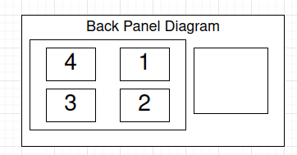
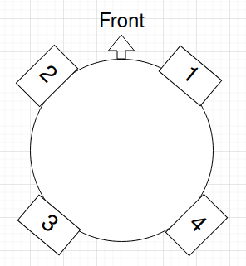

Turtlebot Navigation:
Threat Field Generation:
Projector system:

